**Lecture**

**Additive Technology (CAD, 3D Printing) in Industry 4.0**

**To understand all about Additive Technology (CAD, 3D Printing) in Industry 4.0.**

**Definition of 3D Printing or Additive Manufacturing**

A 3D object can be defined as, "An object or structure that has three dimensions which includes width, length, and height.”

3D printing can be defined as; "Structuring a three-dimensional object in its physical configuration from its digital form”

3D printing is also known as additive manufacturing due to the process of layering it involves. Both terms are used synonymously, digital printing is another term used for this purpose which you might have heard as well.

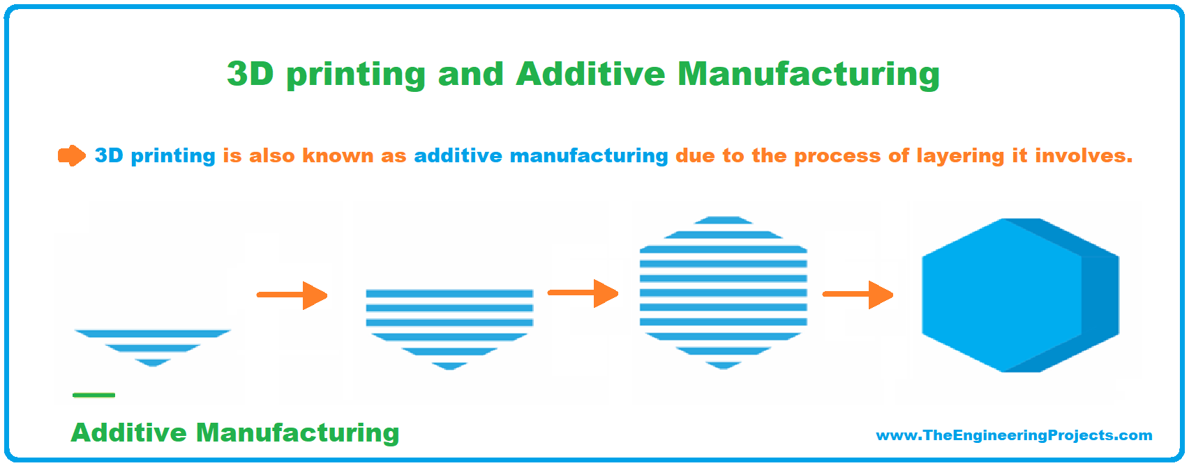

**Figure 1.** Brief about 3D Printing or Additive Manufacturing

Additive manufacturing is the opposite of subtractive manufacturing which was used widely in the past involving gradual removal of layers from a solid block of any material either be wood or metal to form a 3D object.

Additive manufacturing as the name indicates is the layer by layer deposition of a specific material to form a 3D shape or structure.

This technique can be employed in powders be it glass, ceramic, metal and resins in liquid form.

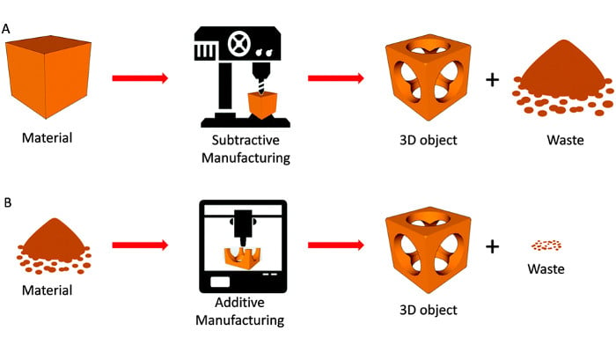

**Figure 2.** Subtractive manufacturing versus Additive manufacturing

**Process Involves 3D printing or Additive Manufacturing**

A few basic processes that are involved in 3D printing which are: -

1. **Modeling:** 3D printing begins with the process of designing the product in digital form using software like AutoCAD, solid works, etc.
2. **STL File Format:** STL file format is mostly used in Stereolithography. It is also called Standard Tessellation Language or Standard Triangle Language STL file format is used for describing the surface geometry of an object to be printed by the 3D printer before the process starts.
3. **3D Slicing:** 3D slicing is the process of breaking down a design into several layers. A slicer generates a G code which helps in providing instructions to the 3D printer that is how the print process should be carried out.

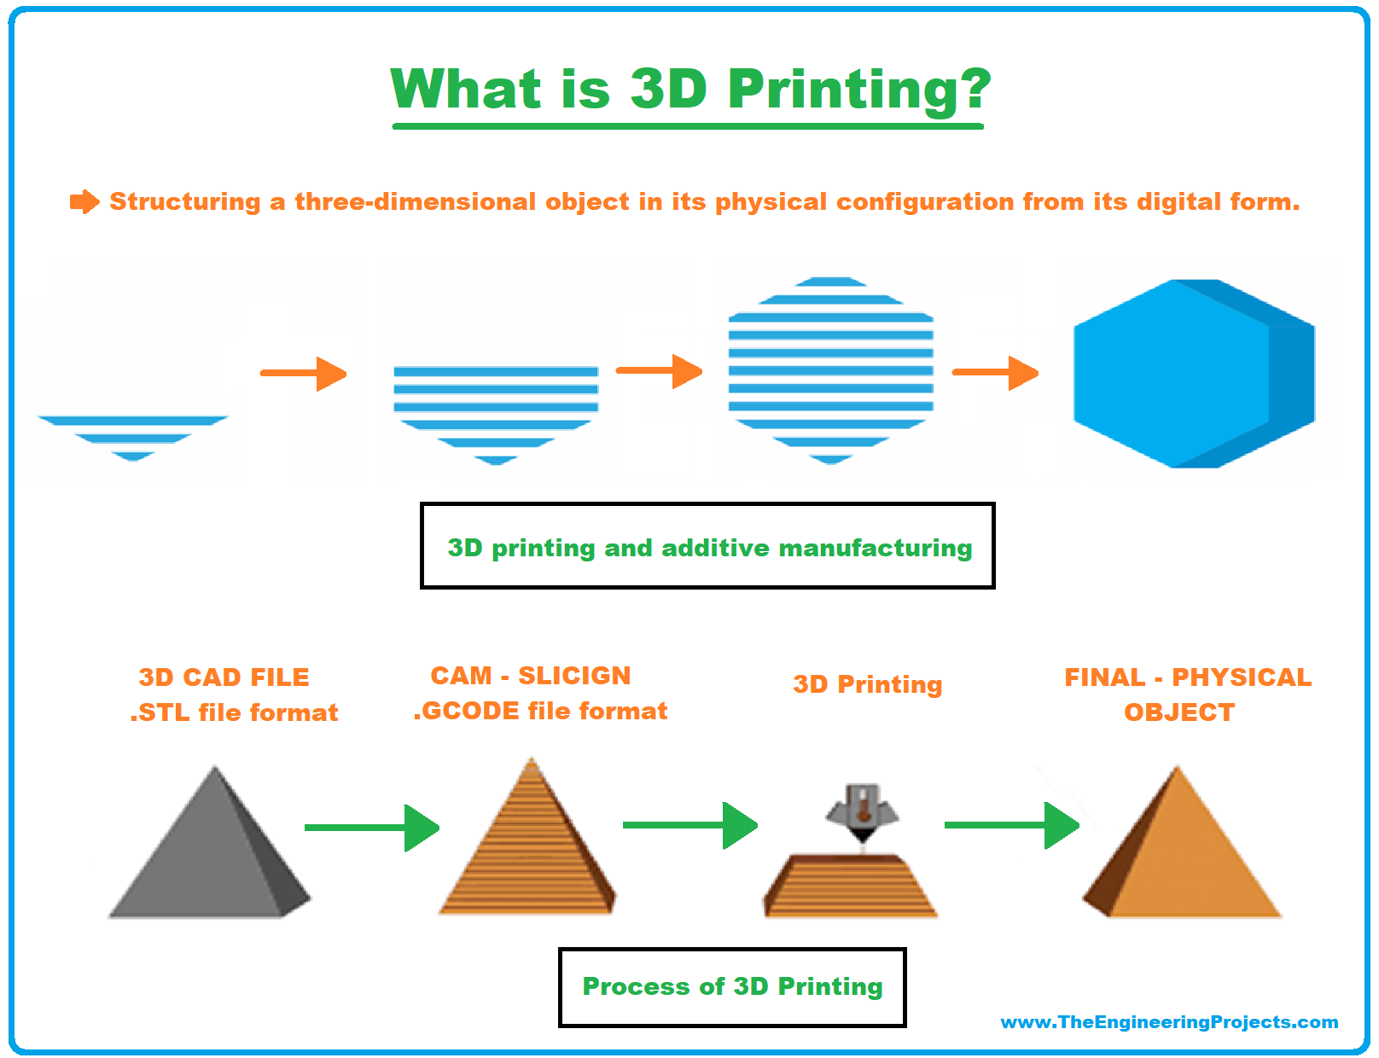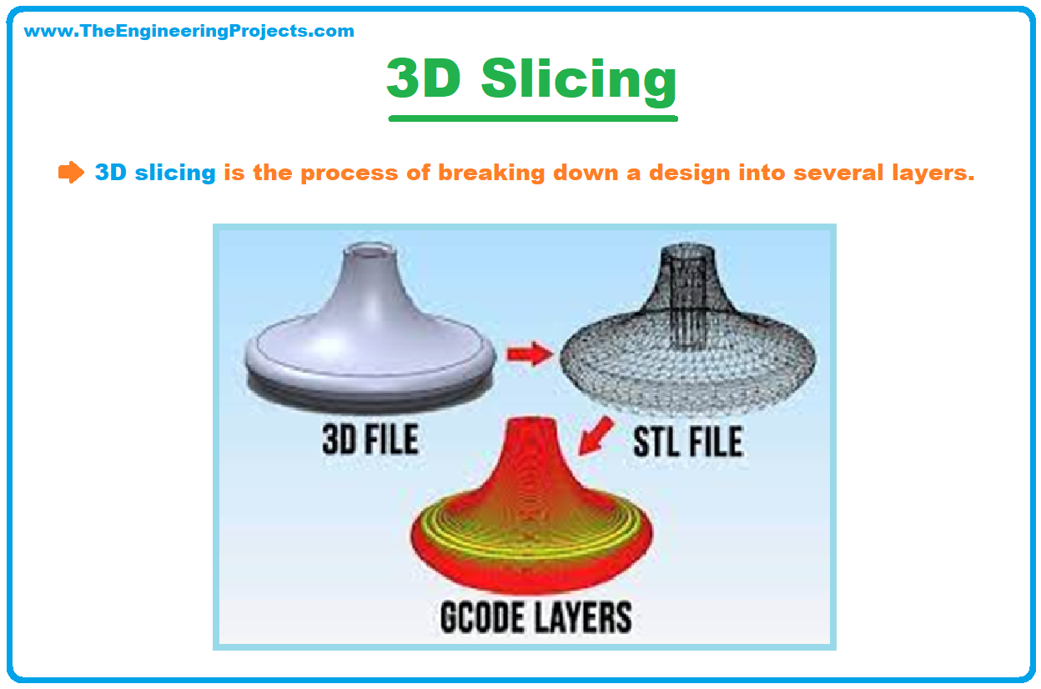

**Figure 3.** Subtractive manufacturing versus Additive manufacturing

**An Introduction to Additive Manufacturing (Also known as 3D printing) in Industry 4.0**

Industrial revolution 4.0, or simply Industry 4.0, is nothing but a reference to the fourth revolution of industry. Since the evolution of programmable computer systems during Industry 3.0, the preceding form, brought us closer to Industry 4.0. However, in extension to Industry 3.0, Industry 4.0 can be identified as an intelligent and smart system with the association of artificial intelligence (AI), big data, cloud computing, and so forth. In other words, the architecture of Industry 4.0 incorporates different technologies such as autonomous robots, Internet of Things (IoT), additive manufacturing (AM), cyber security, AI, big data analytics, cloud computing, vertical and horizontal system integration, and augmented reality.

AM is well-equipped within Industry 4.0, despite its very well-known limitation of low production rates and topological quality. The former one is the robustness; one should be very aware of this salient feature of 3D printing, which brings the total outcome of many machines exposed through a single machine. In brief, a single computer-aided design (CAD) model can be realized as a product without passing through different machining processes and tools. One machine is quite enough to claim a decent product, and this represents a mechanical robustness AM can offer. Additive manufacturing is a smart manufacturing process, which is manageable with the intelligent system, without compromising its customizable edge. Intelligent systems like IoT devices are gadgets processed with the technology to receive and to response to the environment around its location. Another dimension is that AM promotes smart factories.

Additive Manufacturing (AM) is an appropriate name to describe the technologies that build 3D objects by adding layer-upon-layer of material, whether the material is plastic, metal, concrete, etc.

For general discussion purposes many people, including Additive Manufacturing “AM” experts, use the terms “3D printing” and “AM” interchangeably. For more detailed or technical discussions, the term AM is often favored and can refer to printing steps as well as considerations for finishing and inspecting printed parts.

3D printers were born commercially in the mid to late 1980s and heavily leveraged foundational technologies including computer “CNC” control, 2D printing, and laser development. In the 1990s many foundational principles of AM were developed, improved, patented, and commercialized. By the 2000s, AM technologies had matured and were being adopted primarily for commercial prototyping. In the 2010s, the foundational patents for most of the original 3D printing methods expired and a new wave of interest and resources expanded the industry. This expansion made consumer or hobbyist-grade 3D printers more accessible. Today, AM is getting faster and more reliably and growing into a mainstream manufacturing technique not just for prototypes, but for advanced part production. 3D printer formats are also expanding in size and variety to include more robotic and larger-scale gantry platforms. Hybrid machines are starting to emerge to help fulfill the full promise of AM. Software for simulating and controlling 3D printing is also achieving maturity.

**Why is AM Important in Industry 4.0?**

AM is an advanced and innovative manufacturing technology that can fabricate machines and components by adding materials in succession following the digital path generated by the computer-aided design (CAD) model of the component being produced. AM has positioned itself as the backbone of Industry 4.0 for the manufacturing world. The flexibility offered by this revolutionary technology has changed the manufacturing world from what it used to be. In the past, to manufacture a new product, it would go through a series of manufacturing operations and processes. The product went through iterative design processes, which are cumbersome and time consuming. The designer is not only faced with the problem of designing a product that can perform the intended function with a

high level of reliability, but the designer is also confronted with the problem of making a design that can easily be manufactured given the limitation of the conventional manufacturing (CM) processes. This often leads to breaking down of the product to be manufactured into several parts that are later assembled. With these constraints, the designer had to change design several times before a final product design is achieved. After the design process, the next stage is prototype building, which takes a lot of time to achieve, and is then followed by testing. All these stages of the manufacturing processes need to be completed before the final product is manufactured which makes the time-to-market to be long. AM has the capability to shorting this long process because the designer does not need to be worried about how the product will be manufactured. The only problem the designer is confronted with, is to design a product that can perform the intended function and with the highest quality. No matter the complexity of a product, AM has the capability to manufacture with ease, so long as it can be drawn using any available CAD software. Another interesting thing about AM is that it is possible to manufacture a product using composite materials and functionally graded materials in one manufacturing run. What this means to Industry 4.0 is that a product can be designed at a particular location in the world and the same product is manufactured in another location in the world, which is made possible using IoT, which is one of the innovations that power Industry 4.0. The benefit of this is that a product does not need to be produced in a certain part of the world and shipped to another part of the world, which will in turn reduce time to market as well as reduce the overall cost of production, and a cheaper product is ascertained. A production process can be controlled remotely from any part of the world. The AM process involves five basic processes that make the characteristics of Industry 4.0 possible and make AM the basic tool for the fourth industrial revolution.

One of the most difficult challenges is making something for the very first time. 3D printers excel at making new things. In fact, an early widespread use for 3D printers was “rapid prototyping” – a term by which the industry was known for a couple of decades.

**Freedom of shape**

Most products that are mass produced are made using a mold or casting pattern. That means that the parts are designed so that they performance well as products AND so they can be made using molding or casting. The manufacturing method sets a second set of design requirements that has a significant impact on the types of shapes that can be readily made. AM allows for far fewer constraints on product design than molding or casting. AM enables manufacturing of freeform, elegant, and even “complicated” designs that are not practical to make using molds or castings, but often deliver higher or smarter part performance.

3D printers also excel at making something different every time they are used. This makes them one of the most flexible manufacturing solutions on the market. For products that are customized or personalized such as implants or hearing aids, 3D printing can make slightly different shaped parts each time without the need to create or change a mold or casting pattern.

**Volume & Economics**

Production quantity or volume and economics also plays a role here. Although the cost per-part for molding or casting is generally the lowest for mass producing millions of parts, it requires “tooling” such as a mold or casting pattern to be made first. If the required number of parts to be made is relatively few, directly printing parts using AM can be more cost effective, because making dedicated tooling can be avoided.

**Freedom of Composition**

3D printers can make parts using a wide variety of materials. Some types of 3D printers can make parts using different materials or even blend materials together when making parts. This capability lets you put high performance materials where they are most needed such as at surfaces, edges, or corners. It also lets people change the stiffness, hardness, and density of parts. Tailored temperature or corrosion resistance can also be imparted with change in composition. This is a powerful capability that is still emerging enabled by AM.

**Reducing Waste**

AM has the potential to be less wasteful than other manufacturing technologies, even other digitally driven manufacturing technologies such as computer controlled “CNC” machining. This depends on the design of the part and the alternative manufacturing methods, but conceptually 3D printers primarily put material where it is needed without wasting very much.

**Easy to use**

The development of AM in tandem with personal computers makes it one of the easiest technologies to learn how to use. No software programming skills are required to 3D print parts since the modelling and manufacturing preparation software are all based on familiar graphical user interfaces.

These benefits help make Additive Manufacturing “AM” one of the fastest growing and most exciting technology areas. Please note that AM technology is not limited to working only in the morning or “a.m.” despite the abbreviation similarity. In fact, this manufacturing technology is computer controlled, so often these machines start running in the daytime and work all through the night without stopping.

**Digital Manufacturing**

Speaking of working non-stop, 3D printers make physical parts from digital computer models. Software makes most of the decisions about how each part is made and controls the actual printing process. That means that 3D printers are a digitally driven manufacturing technique and fit alongside other digitally driven techniques such as CNC machining and laser cutting.

Generally, an operator only interacts with a 3D printer before and after printing (to prepare it to start and then to remove the newly printed parts respectively). During the printing or “build cycle” the operator is not needed, except for perhaps general oversight or occasional tweaks to settings.

**Computerized Models**

How does the part shape or model get into a into the computer? Designers in many industries are using computer aided design “CAD” software to virtually create things before they are physically made. Also, physical items that already exist, can be 3D scanned and stored as a computer model. Most often models for 3D printing are stored in an STL or 3MF file format.

**Working principles of AM**

In contrast to “subtractive” technologies, such as CNC machining, that remove material from the outside in, to shape a part; 3D printers work from the inside out to make parts. Most 3D printers deposit flat layers stacked one upon the next, much like laying bricks or stacking up the layers for a sandwich: first the bottom slice of bread, then meat, some lettuce on top, then a tomato, and finally the top slice of bread. Each layer is added to the next and these layers are joined together to make a part that is very close to the final shape. The way that these layers are joined together is determined by the materials being printed and type of printer being used.

**Materials**

AM can make parts from plastics, metals, ceramics, composites, concrete, and other materials. Most 3D printers make a part using primarily one material called a “build material.” Many non-metals build materials are available in different colors and some printers can make parts with a mixture of different colors printed in. The available number of build materials that are compatible with 3D printers continues to expand. Some printers can use a selection of similar materials to make multi-material parts (think of the way your toothbrush has a stiff handle with softer areas to improve grip). The ability to print from wider selections of materials and in some cases combining disparate materials into one part continues to expand. To print overhanging or bridge-like features, that would otherwise collapse during the build process, extra features or even a separate “support material” may be printed for temporary support as the 3D printer builds up the part.

The different nature of materials that can be printed has led to more than 50 different 3D printing technologies. However, standards bodies have agreed on 7 categories (ISO/ASTM52900-21) that summarize the main sets of operating principles for 3D printers as explained in a couple of sections.

**Finishing Parts after Printing**

Rarely is a 3D printed part finished when it leaves a printer. Parts are normally built adhered to a surface that is often called a “build plate” or substrate and need to be removed. Often “supports” (structures or support material) need to be removed. Depending on the materials printed and the desired end-use of the parts, additional steps may be needed. For example, parts may need to go into an oven or furnace to finish curing or improve their properties. Also, the part surfaces may need smoothing out. The steps after printing can be referred to as “post-processing” steps. For some 3D printing techniques these steps are simple, but for other they can be extensive.

**Hybrid Manufacturing**

Machines that offer both additive and finishing capabilities together are known as hybrid manufacturing machines. The most common types of hybrid machines combine one type of AM with CNC machining so parts can be printed and finished in the same setup. Some hybrid machines can combine more than two processes such as additive, subtractive, and inspection offering the capability of a microfactory.

**Advantages of Additive Manufacturing**

3D printing first gained traction as a tool for rapid prototyping, but as the technology has advanced, there are now numerous advantages to choosing additive manufacturing for production. Here are some of them: -

1. Design freedom
2. Material options
3. Lightweighting
4. Speed
5. Less waste
6. Cost savings
7. On-Demand Production

**Application of Additive Manufacturing**

1. Medical Equipment
2. Toys And Games
3. Assembly Parts
4. Art and Design
5. Jewellery
6. Automotive Industry
7. Architectural Designs